

OBJECT ORIENTED PROGRAMMING PROJECT REPORT

- SMART HOME DEVICE SIMULATOR

- Submitted By:
Name | Reg. No.
Muhammad Ammar Umer | 2025-SE-380
Muhammad Zeeshan | 2025-SE-391
Aasia Nadeem | 2025-SE-351
Umme Habiba | 2025-SE-404

- Submitted To:
Ms. Shanfa Irum
- Department:
Computer Science
- University:
University Of Engineering and Technology, Lahore New Campus
- Submission Date:
7 June 2026
- Introduction:
The Smart Home Device Simulator is a console-based C++ application developed using Object-Oriented Programming (OOP) principles. The project simulates a smart home environment where users can manage devices such as thermostats, smart lights, security cameras, smart locks, and speakers.
The system is built on a well-defined class hierarchy rooted in an abstract base class (SmartDevice), and supports automation rules, energy logging, and role-based user authentication.
The system allows users to:
- Add and manage smart devices across multiple rooms
- Control device behaviour (toggle, schedule, configure)
- Monitor real-time device status
- Group devices by room under a central SmartHome controller
- Execute automation commands triggered by conditions
- Log and analyse energy consumption per device

- Objectives:
- Implement OOP concepts practically in a real-world simulation
- Understand inheritance and polymorphism through a multi-level class hierarchy
- Use abstract classes and pure virtual functions to enforce device interfaces
- Apply dynamic memory allocation with pointers to base class
- Implement operator overloading (== and <<) on SmartDevice
- Use multiple inheritance via the Schedulable interface
- Build a menu-driven, modular, and extensible application

- Problem Statement:
- Modern smart homes contain multiple connected devices that share common behaviours but also have specialised functionalities. Managing these devices efficiently requires a flexible and scalable software structure.
- This project develops a simulation system capable of handling different smart devices through a unified polymorphic interface.
- We use Automations and Energy Consumption reporting to make the system efficient and realistic.

- Different Phases:
- Designing
- Code Development
- Integration of Files
- Testing and Debugging
- Designing:
- Designing Classes:
The system is designed around 12 classes, structured in a three-tier hierarchy:
- SmartDevice (Abstract Base Class) — defines common attributes and the device interface
- SmartLight, Thermostat, SecurityCamera, SmartAppliance — direct concrete subclasses
- SmartLock, SmartSpeaker — extend SmartAppliance (two-level inheritance)
- UserAuthentication, Room, SmartHome, Automation, EnergyLog — supporting classes
- Designing the UML:
A formal UML Class Diagram was designed before implementation. The diagram shows:
- Inheritance arrows from each device class to SmartDevice
- Dashed implementation arrow from SmartLight and Thermostat to the Schedulable interface
- Composition diamond from SmartHome to Room, and Room to SmartDevice
- Association line from SmartHome to Automation (1 to 1..*) and EnergyLog (0..*)

- UML Class Diagram:
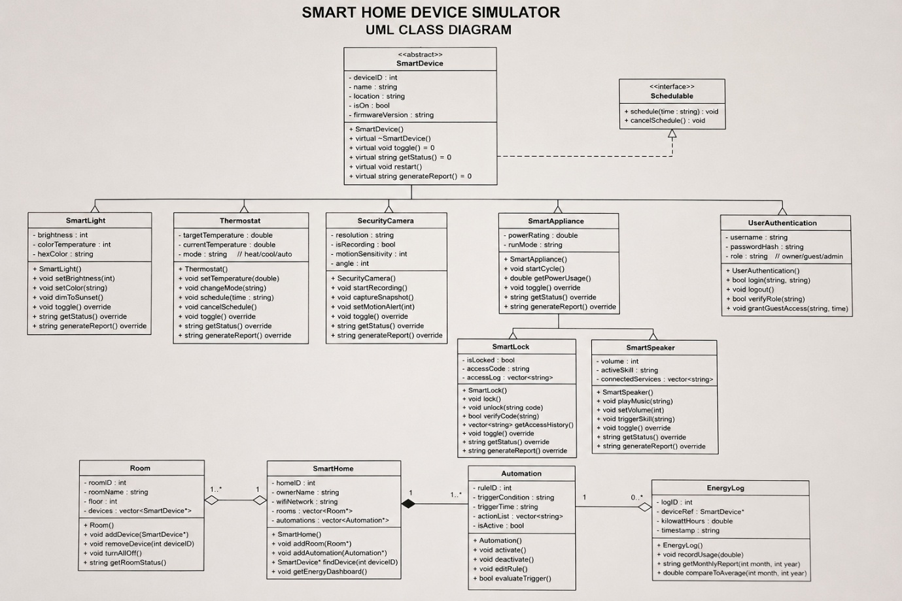
Figure: UML Class Diagram

- Code Development:
- SmartDevice — Abstract Base Class
SmartDevice is the root of the hierarchy. It stores deviceId, deviceName, location, firmwareVersion, and the protected isOn flag. Three pure virtual functions enforce the device interface. It also includes a static count, operator==, and friend operator<<.
class SmartDevice {
private:
int deviceId;
string deviceName, location, firmwareVersion;
protected:
bool isOn;
public:
static int count;
SmartDevice(int id, string n, string loc, string v);
SmartDevice(const SmartDevice& obj); // Copy Constructor
virtual ~SmartDevice();
virtual void toggle() = 0; // pure virtual
virtual void getStatus() const = 0; // pure virtual
virtual void generateReport() const = 0; // pure virtual
virtual void restart(); // default implementation
bool operator==(const SmartDevice& other);
friend ostream& operator<<(ostream& out, const SmartDevice& d);
};

- SmartLight — Multiple Inheritance
SmartLight inherits from both SmartDevice and the Schedulable interface. It adds brightness (0-100%), colour temperature (Kelvin), and hex colour string. The dimToSunset() method sets warm amber preset automatically.
class Schedulable {
public:
virtual void schedule(const string& time) = 0;
virtual void cancelSchedule() = 0;
virtual ~Schedulable() = 0;
};

class SmartLight : public SmartDevice, public Schedulable {
int brightness, colorTemperature;
string hexColor, scheduledTime;
public:
void setBrightness(int b);
void dimToSunset();
void toggle() override;
void getStatus() const override;
void schedule(const string& time) override;
};

- Thermostat — Schedulable + Mode Control
Thermostat also implements Schedulable. It maintains targetTemperature, currentTemperature, and mode (heat/cool/auto). Temperature validation prevents values outside 5–35°C.
class Thermostat : public SmartDevice, public Schedulable {
double targetTemperature, currentTemperature;
string mode, scheduledTime;
public:
void setTemperature(double tt);
void changeMode(const string& m);
void schedule(const string& time) override;
void toggle() override;
void getStatus() const override;
};

- SecurityCamera
SecurityCamera stores resolution, motionSensitivity (1-10), angle, and recording state. It supports startRecording(), captureSnapshot(), and setMotionAlert().

- SmartAppliance, SmartLock, SmartSpeaker
SmartAppliance is a mid-level concrete class with powerRating and runMode. SmartLock extends it with a PIN-based locking system and timestamped access log. SmartSpeaker adds volume, activeSkill, and connectedServices.
// SmartLock — unlock with access logging
void SmartLock::unlock(const string& code) {
if (verifyCode(code)) {
isLocked = false;
accessLog.push_back(timestamp() + " | UNLOCKED (success)");
} else {
accessLog.push_back(timestamp() + " | UNLOCK FAILED (wrong code)");
cout << "Access denied.\n";
}
}

- UserAuthentication
Manages credentials and role-based access (owner/admin/guest). Passwords are stored as hashed values using std::hash. Owners can grant temporary guest access.
bool UserAuthentication::login(const string& user, const string& pass) {
if (user == username && hashPassword(pass) == passwordHash) {
cout << "Login successful for " << username << "\n";
return true;
}
cout << "Login failed\n";
return false;
}

- Automation Engine
Automation stores a triggerCondition string. When evaluateTrigger() is called with a matching condition, it fires a std::function<void()> callback that performs device actions. This allows flexible, data-driven rule evaluation.
bool Automation::evaluateTrigger(const string& current) {
if (isActive && current == triggerCondition) {
cout << "[Automation #" << ruleID << "] Trigger fired!\n";
if (actionCallback) actionCallback(); // lambda executes here
return true;
}
return false;
}

// Registered in main():
nightMode->setActionCallback([&]() {
light1->dimToSunset();
lock1->lock();
});

- Room and SmartHome
Room is a container for SmartDevice* pointers. SmartHome aggregates Room* and Automation* objects. It can locate any device by ID across all rooms and broadcast trigger conditions to all automations.
void Room::turnAllOff() {
for (auto* device : devices)
if (device->getIsOn())
device->toggle(); // runtime polymorphism
}

SmartDevice* SmartHome::findDevice(int id) const {
for (const auto* room : rooms)
for (auto* dev : room->getDevices())
if (dev->getDeviceID() == id) return dev;
return nullptr;
}

- EnergyLog
EnergyLog records cumulative kilowatt-hour usage for a device. It generates monthly cost reports (at $0.12/kWh) and compares usage against an average baseline.
- Integration of Files:
The project uses a standard C++ header/implementation split. Each class has its own .h and .cpp file. All files are compiled together using a Makefile or a single g++ command.
- Project File Structure:
SmartHomeSimulato/
├── include/
│ ├── SmartDevice.h (abstract base + Schedulable)
│ ├── SmartLight.h (+ Schedulable)
│ ├── Thermostat.h (+ Schedulable)
│ ├── SecurityCamera.h
│ ├── SmartAppliance.h
│ ├── SmartLock.h (extends SmartAppliance)
│ ├── SmartSpeaker.h (extends SmartAppliance)
│ ├── UserAuthentication.h
│ ├── EnergyLog.h
│ ├── Automation.h
│ ├── Room.h
│ └── SmartHome.h
│ └── Menu.h (Hold All Menu)
└── src/
├── (all .cpp files)
└── main.cpp

- Build Command (Windows):
g++ -std=c++17 -Iinclude src/SmartDevice.cpp src/SmartLight.cpp ^
src/Thermostat.cpp src/SecurityCamera.cpp src/SmartAppliance.cpp ^
src/SmartLock.cpp src/SmartSpeaker.cpp src/UserAuthentication.cpp ^
src/EnergyLog.cpp src/Automation.cpp src/Room.cpp ^
src/SmartHome.cpp src/main.cpp -o SmartHomeSimulator.exe

I use Cmake to Combine Files and make MAKEFILE for all Files Compilations which execute the command above.

- Testing and Debugging:
The project was tested module by module. Each class was verified independently before integration. The following test cases were executed:
- Test Case 1: User Management
Test all Features of User Management like Register User, Remove User and View Users.
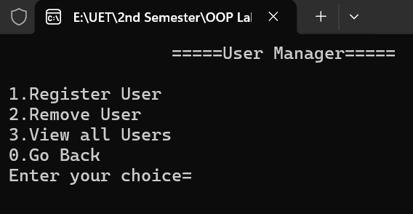
Figure: User Management Output

- Test Case 2: House Management
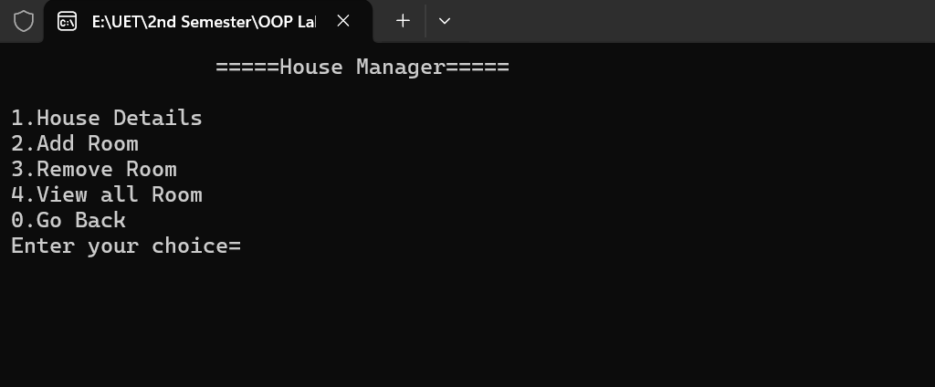
Test all Features of House Management like House Details, Add Room, Remove Room and View Users.
Figure: House Management Output

- Test Case 3: Device Management
Test all Features of Device Management like Add Device, Remove Device, Device Control, Room Grouping, View all Devices.
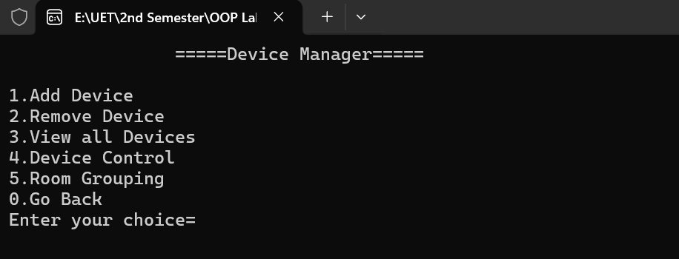

Figure: Device Management Output
- Test Case 4:
Test all Features of Automation Management like Add Automation, Remove Automation, Activate Automation, Deactivate Automation, View all Automations.
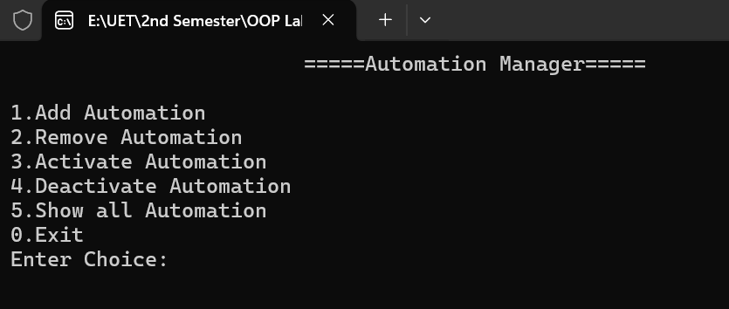

Figure: SmartSpeaker and SmartAppliance Output

- OOP Concepts Applied:
- Abstraction
SmartDevice is declared abstract through three pure virtual functions. No object of SmartDevice can be instantiated directly, and every derived class must provide its own implementation.
- Encapsulation
All class attributes are private or protected. Access is provided exclusively through getter and setter methods, ensuring no external code can corrupt internal state directly.
- Inheritance
Single inheritance: SmartLight, Thermostat, SecurityCamera, SmartAppliance inherit from SmartDevice. Two-level inheritance: SmartLock and SmartSpeaker inherit from SmartAppliance.
- Multiple Inheritance
SmartLight and Thermostat inherit from both SmartDevice and the Schedulable interface, enabling scheduling functionality alongside the standard device interface.
- Polymorphism
Room stores a vector<SmartDevice*>. Calling toggle() or getStatus() on any pointer invokes the correct overridden implementation at runtime through virtual dispatch.
- Operator Overloading
SmartDevice overloads operator== to compare devices by deviceId, and declares operator<< as a friend function for structured console output.
- Dynamic Memory Allocation
Room and SmartHome use vectors of raw pointers (SmartDevice*, Room*, Automation*). In main(), smart pointers (unique_ptr) are used to manage object lifetimes safely.

- Conclusion:
The Smart Home Device Simulator successfully demonstrates the application of Object-Oriented Programming principles in a practical, real-world modelling scenario. The project implements a clean class hierarchy rooted in an abstract base class, uses multiple inheritance for optional capabilities, and leverages runtime polymorphism for generic device management.
The automation engine introduces functional-programming elements through std::function callbacks, while the SmartLock's timestamped access log demonstrates practical use of data structures within a class. User authentication with hashed passwords and role-based access control adds a security layer to the system.
All modules compile cleanly under C++ with no warnings and execute correctly as verified by program output testing. The project serves as a strong foundation that can be extended with file I/O persistence, a graphical interface, or network communication in future work.

